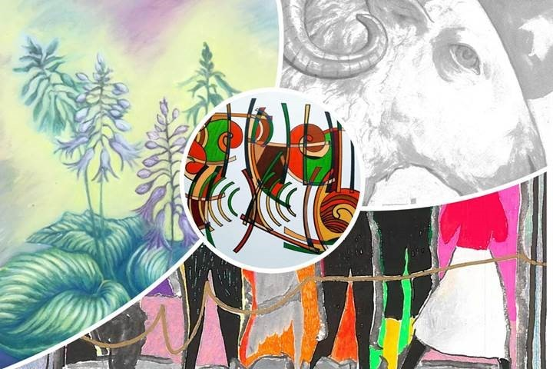
PRESS RELEASE
Connections - Wholly Holistic Exhibition Graphic
CONTACT
Poppy Evans
poppy@santosa.co.uk
0131 555 6255

RELEASE DATE
28th April 2021

ANNOUNCING ‘CONNECTIONS – WHOLLY HOLISTIC’ ART EXHIBITION & ON-LINE EVENTS
at: Santosa Wellness Centre Edinburgh
DATES: May1st – 30th June2021
Within the peaceful Wellness Centre and Café of Santosa, a group of artists come together in the creative spirit which flows in these challenging times. They would like to invite others to participate in this expression of the human spirit, bringing openness and imagination into exploring our connections within the community and the natural world.

The artists - Jessica Barbagallo, Katerina Campbell, Pauline Flannery, Sally Freedman, Tom Wallace, Michael Jessing, Lizzie Smith and Sarna - see the thread of words, images, nature, and spirit weave through their work.

Connections - Wholly Holistic events and workshops include word- movement, spoken word, healing sounds, storytelling and more. These events take place on Saturdays at 6 pm.

The exhibition sees three book launches: Three Miles of Rice Pudding by Tom Wallace, Mermaid on Legs by Lizzie Smith and Shepherd Project by Michael Jessing.

A proportion of the proceeds from sales of the work donated to the “Learning for a Change Nepal” charity.
END

