PRESS RELEASE: EMBARGOED UNTIL 18TH AUGUST 2020 (@ 12PM BST)
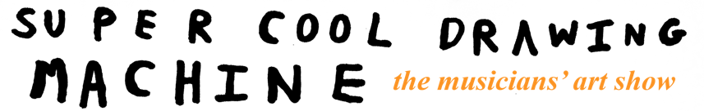

Yuppies Music presents Super Cool Drawing Machine, a touring exhibition of musicians’ “other” artwork. The exhibition will take up residency at independent music venues in York, Birkenhead, Margate, Bristol and London, from November 2020 to January 2021. See full dates and venues listed below.

Rising from the ashes of the Covid-19 crisis, Super Cool Drawing Machine is a celebration of the visual art created by a host of internationally acclaimed, touring musicians. It is set to bring engaging and exciting artistic creations – and a much-needed dose of fun – back into the UK’s treasured music spaces.

Drawn from diverse musical genres and backgrounds, the artists include trailblazing saxophonist and figurehead of the UK Jazz scene Shabaka Hutchings, Mercury-nominated Welsh singer/producer Cate Le Bon, experimental folk musician Richard Dawson, African American experimentalist Lonnie Holley (who has previously exhibited in the likes of the Turner Contemporary gallery), and celebrated drummer/composer Seb Rochford, as well as members of This is The Kit, Mammal Hands, Haiku Salut, Snapped Ankles and many more. (Full list below)

They will exhibit paintings, photography, drawings, ceramics, digital instillations, recycled arts, sculpture and furniture – a colourful and interactive array of artworks for the open minded and curious. There will also be a gift shop where fans can buy merchandise.
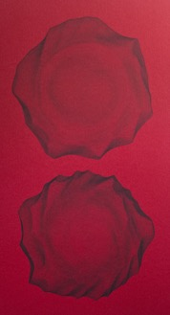Leafcutter John - Plots
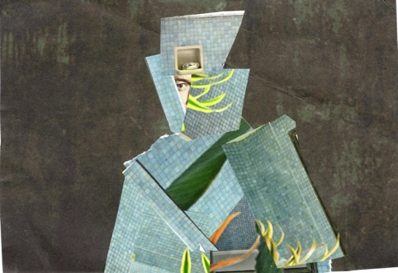
Ed Dowie - Collage
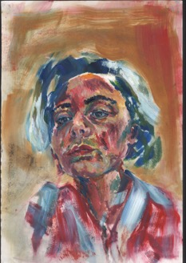Holysseus Fly – Self Portrait

The idea for SCDM was conceived by Sam Tucker of live music agency Yuppies Music, after seeing his core business shattered overnight by the effects of the Covid-19 pandemic. Like many, he felt a need to engage with new projects in the new reality, rather than allow his corner of the creative world to stagnate.

Tucker elaborates: “Early on during lockdown, after the crushing anxiety relating to the collapse of the live events industry, friends, musicians and promoters started talking about the idea of adjusting. We were prepared to adjust, but how?”

The first seed was unwittingly sown in a conversation with a friend, the musician Leafcutter John. “He suggested that I share some of the artwork that I personally was working on during lockdown - to use this time as an opportunity to be more open with the things I create when not busy booking tours”, explains Tucker. He submitted some pieces to Grayson Perry’s Art Club, leading to one of his handmade puppets being included in the popular lockdown show. “It gave me a real boost, and a feeling of connection with the outside world, and that’s when the idea for SCDM started tumbling around in my head. Except instead of showcasing my own efforts, I could put new work by “real artists” from the music world on display”, he laughs.

“Every time I thought about it, another musician/artist sprang to mind. And the more I mentioned it, the more suggestions came back, beginning a discovery process and an open exchange of ideas and fun conversations. It has been incredible to see the visual manifestations of some of my favourite musicians’ creativity, and I hope that others will feel the same.” >>>

The exhibition reflects this sense of fun in a varied and balanced collection of pieces – from homemade fishing lures and found/recycled art to more traditional forms. The overall aesthetic is accessible and free of pretension, with a colourful, “folk art” feel. And when plotting the route, the usual booking agent priorities shifted in favour of hitting up all corners of the country, to make it as inclusive and open as possible.

By putting a safe and sensible creative offering into dormant music venues, SCDM aims to help bridge the gap for audiences, artists and venues alike – reconnecting music lovers with their culture, and supporting artists’ creativity – while the future of live touring remains uncertain.

“There is a lot of un-presented artwork made by shy musicians, and now is a great time to get that stuff out to the curious”, Tucker adds. “We just ask that the visual arts world accept these musicians into the fold for a bit, just while we all figure out what’s going on…”

NOTES FOR EDITORS:

Yuppies Music is a Somerset based live music booking agency run by Sam Tucker and Dexter Millest.

Listen to the Super Cool Drawing Machine Contributors’ Spotify Playlist
Website: www.SUPERCOOLDRAWINGMACHINE.com
Promo folder for assets incl. press pack, hi res images: https://bit.ly/SuperCoolDrawingMachinePROMO

Several artists are available for interview about the project, including:
Shabaka Hutchings
Kate Stables (This is the Kit)
Richard Dawson
Leafcutter John
Rachael Dadd

Full list of 29 showcasing artists (alphabetical order):
MAMMAL HANDS
PETER BRODERICK
POPPY ACKROYD
RACHAEL DADD
RICHARD DAWSON
RHODRI DAVIES
ROZI PLAIN
SEB ROCHFORD
SHABAKA HUTCHINGS
SNAPPED ANKLES
TARA CLERKIN
THIS IS THE KIT
YAMA WARASHI
YUMI AND THE WEATHER

BEX BURCH (VULA VIEL)
BRYONY JARMAN-PINTO
night flight: ‘CATE LE BON
H.HAWKLINE
TIM PRESLEY’
CLOUDSHOES
DAISUKE TANABE
ED DOWIE
FRÅNÇOIS & THE ATLAS MOUNTAINS
HAIKU SALUT
HOLYSSEUS FLY
ICHI
JEFFREY LEWIS
LEAFCUTTER JOHN
LONNIE HOLLEY

Full list of dates:

The Crescent – YORK – November 5th - 8th 2020 Event Page

Future Yard – BIRKENHEAD – November 12th - 15th 2020 Event Page

Elsewhere – MARGATE – November 26th - 29th 2020 Event Page

Colston Hall Foyer – BRISTOL – January 14th - 17th 2021 Event Page

Studio 9294 – LONDON – January 21st - 24th 2021 Event Page

Press/radio enquiries: Rosie James at Fever To Tell PR rosie@fevertotell.com / 07891 225654
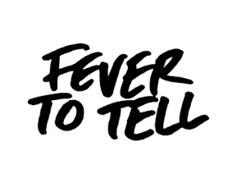

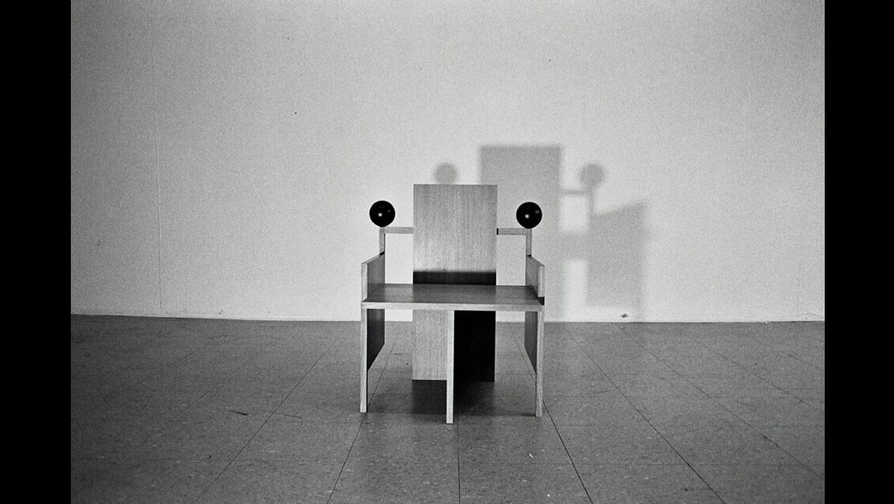
Cate Le Bon - Chair

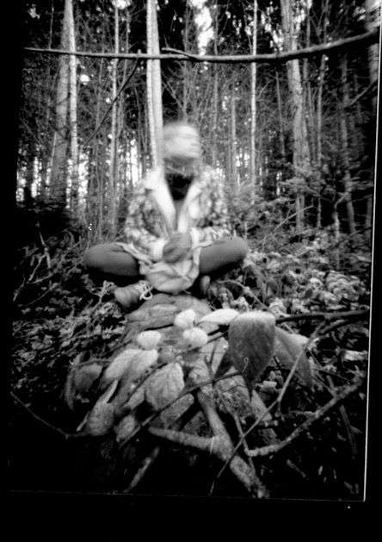Kate Stables (This Is The Kit) – Pinhole Photography
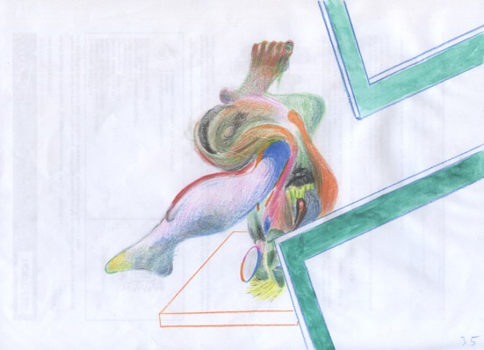Francois & the Atlas Mountains - Animation

Press/radio enquiries: Rosie James at Fever To Tell PR rosie@fevertotell.com / 07891 225654

